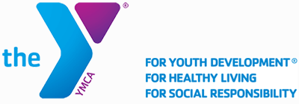

RE: Your Offer letter [Rescinded]
Dear Ms. Mulah Xoo,
On behalf of our esteemed organization, I am pleased to offer you a membership opportunity to serve in the position of a Membership Service Team Member in our Boston camp in the state of Massachusetts. You are to serve and report to the Coordinate of Membership Relations.
Duties for this position would include among others; response to emergencies, hygiene and sanitation, handling electronic member registration, attending staff meetings and conducting member tours. The position attracts a daily wage rate of $17 per hour. The expected start date is scheduled at March 23, 2020.
However, we wish to communicate to you that this offer has been rescinded. The emerging Covid-19 pandemic has paralyzed our operations and as a result, we have shut down the organization indefinitely. In consideration of this, we deeply regret to inform you that this position is no longer available.
Please bear with us for now. If similar opportunities arise in our organization at a later date, you are encouraged to resubmit your application.

With regards,

_________________
Jason Kale,
Director, Hiring & Recruitment.
YCMA of Great Boston,
316 Huntington Ave., Boston, MA 02115
Tel: +1 617-927-8060.
Jskale004@ymcaboston.org

